AMINODEN, SAADUDEN P.
BSIT 1-1
Earth & Life Science

ACTIVITY #1
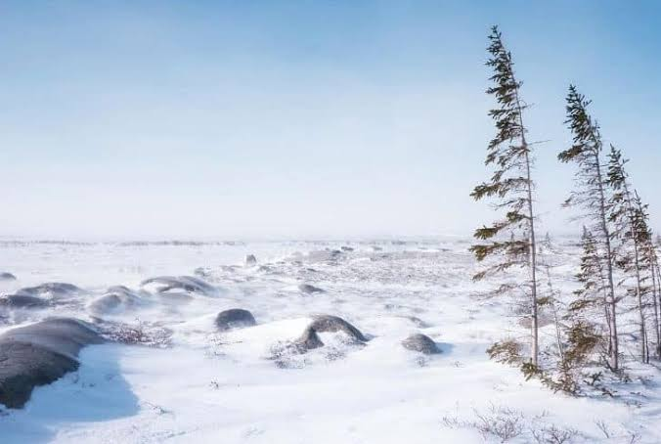
1. TUNDRA
Tundra biome is the coldest biome among the five. Tundra has a very low precipitation just like deserts but it consists of mostly ice and snow and very little amount or almost no trees. It is mostly in the regions below the ice caps of arctic
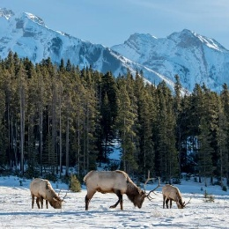
2. TAIGA
Taiga biome is also a cold weather biome but unlike tundra taiga has trees but with also very low precipitation
Taiga biome is mostly both forests and tundra which is found mostly in some countries in the north america.

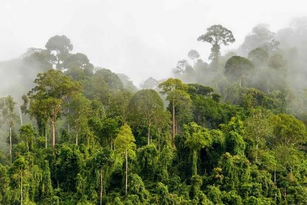
3. TROPICAL RAINFOREST
Tropical rainforest consist of many trees and vegetations which makes it hot, moist and precipitation is very common or sometimes rains happen all year long.

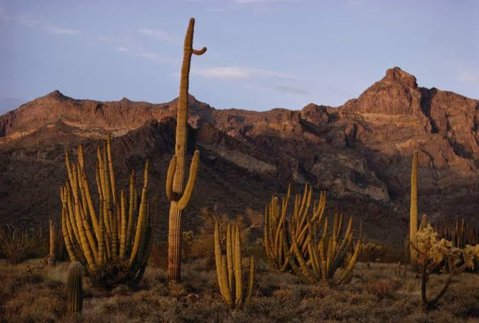
4. DESERT
The desert biome is known as the driest of all the biomes which precipitation is very unlikely. Deserts mostly consist of sands and almost no trees can sometimes survive these biomes except for plants that holds water for a long timr such as cactus.

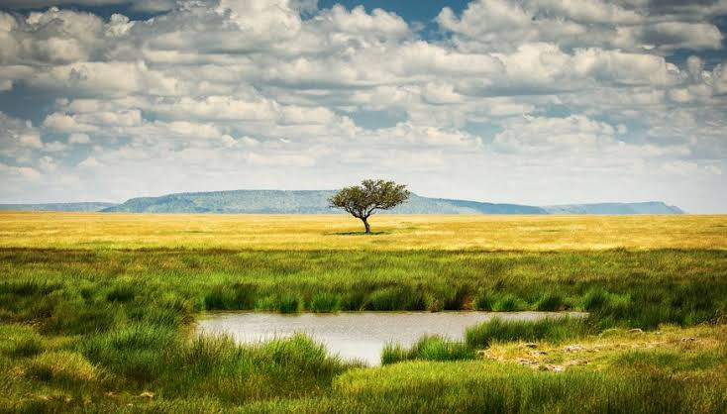
5. GRASSLAND
Grassland is an open flat area full of grass. Often located between temperature forests. Precipitation happens but not enough to sustain growth of trees that’s why it’s mostly dominated by grasses instead. Grasslands are usually for agricultural uses.

2. Of the different terrestrial biomes discussed, Where does the philippines fit in? What are the characteristics that made you say that.

Rains are very common to the philippines because there are alot of trees in our country. Our country consists of huge forestries and mountains. The Philippines is definitely a tropical rainforest as trees are everywhere around the country where precipitation is also very common all year long. Philippines has all the characteristics of a tropical rainforests such as high humidity, hot and very much rains through out the year. Since our country is in the equator I can be very sure as tropical rainforest are mostly on the countries in the equator also there are no other seasons in the Philippines.

C.

